
ACTIVITY REPORT
On

CIPHER QUEST
- Name of the Club: BMSCE ACM STUDENT CHAPTER
- Name of the Activity: Cipher Quest
- Objectives: The event aimed to challenge participants to decode encrypted messages and solve intricate puzzles to save their homeland from impending disaster, fostering teamwork, strategic thinking, and problem-solving skills.
- Date, Time Venue of the Activity:
TOPIC | CIPHER QUEST
DATE/DAY | Sunday, 19th May 2024
VENUE | MEL LAB 2
- Name and details of collaborating agency (if it is collaborative/joint activity): Videsh Educon
- Brief summary of the Programme: The exhilarating event brought together 30 teams of two participants each, who embarked on a quest filled with ciphers and mysteries. The mission was clear: decode the encrypted messages to save their homeland from impending disaster. Each team received a unique zip file containing password-protected folders. The challenge was to decipher various types of codes to unlock these folders, earning 50 points per successfully unlocked folder. Furthermore, teams had to demonstrate their typing accuracy by blind typing sentences given after each successful deciphering.
In the elimination rounds, participants were thrust into a realm of cryptic puzzles. Each team had to decode messages using different cipher techniques. This tested not only their cryptographic skills but also their teamwork and communication under pressure. The goal was to solve these puzzles as quickly and accurately as possible. The teams that performed the best, with the fastest and most accurate decoding and typing, advanced to the final round.
The final round presented a unique challenge with a game called Cryptic Ludo. Unlike traditional Ludo, this version utilized two dice, and teams could use basic mathematical operations on the numbers rolled to strategize their moves. Completing each quarter of the board wasn't straightforward; teams faced additional puzzles like Sudoku, crosswords, and mazes that they needed to solve to progress. This blend of board game strategy and puzzle-solving ensured that only the most versatile and resourceful teams could advance.
Ultimately, four teams made it to the final showdown. They navigated the intricate Cryptic Ludo board, solving puzzles and employing their mathematical skills to move their pawns. The event culminated in an exciting finish, with the winning team successfully navigating all the quarters of the board, demonstrating exceptional problem-solving skills, teamwork, and strategic thinking. This innovative competition provided an engaging and dynamic experience, blending traditional games with modern cryptographic challenges.
- Outcomes: The event helped participants improve their teamwork and problem-solving skills. They also learned to think strategically and quickly under pressure.
- Number of participants:
Number of Faculty | Number of  Non-Teaching Staff | Number of  External Participants | Number of Students
0 | 0 | 2 | 45

- Two or three relevant Photographs of the activity: (Geo-tagged photos are preferable)
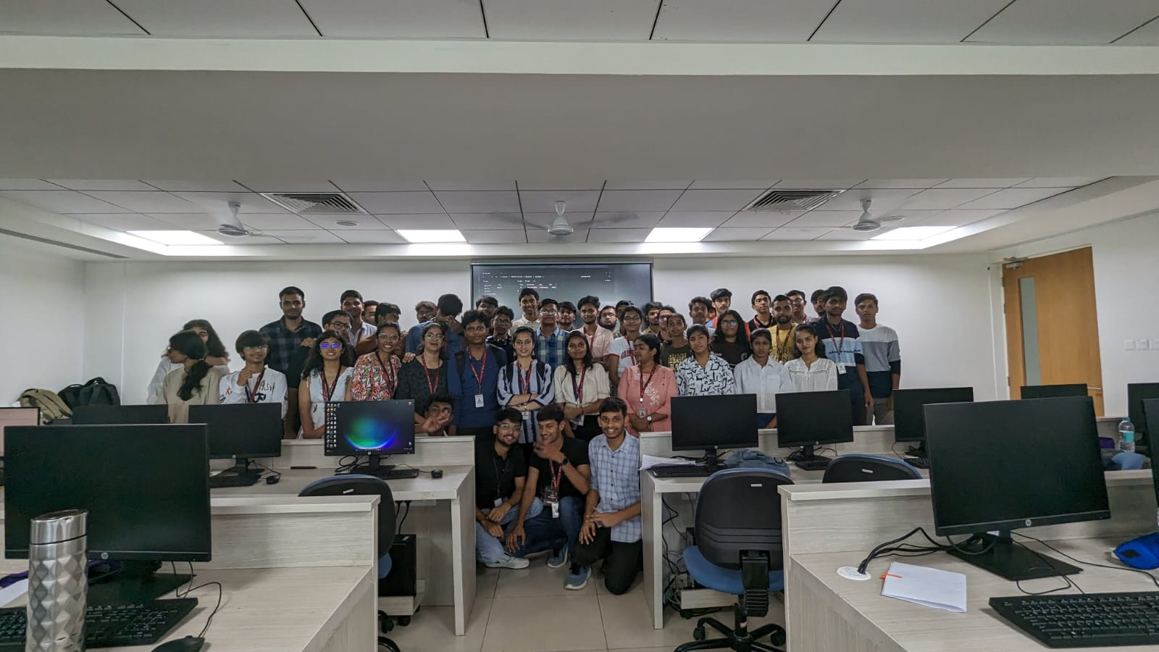

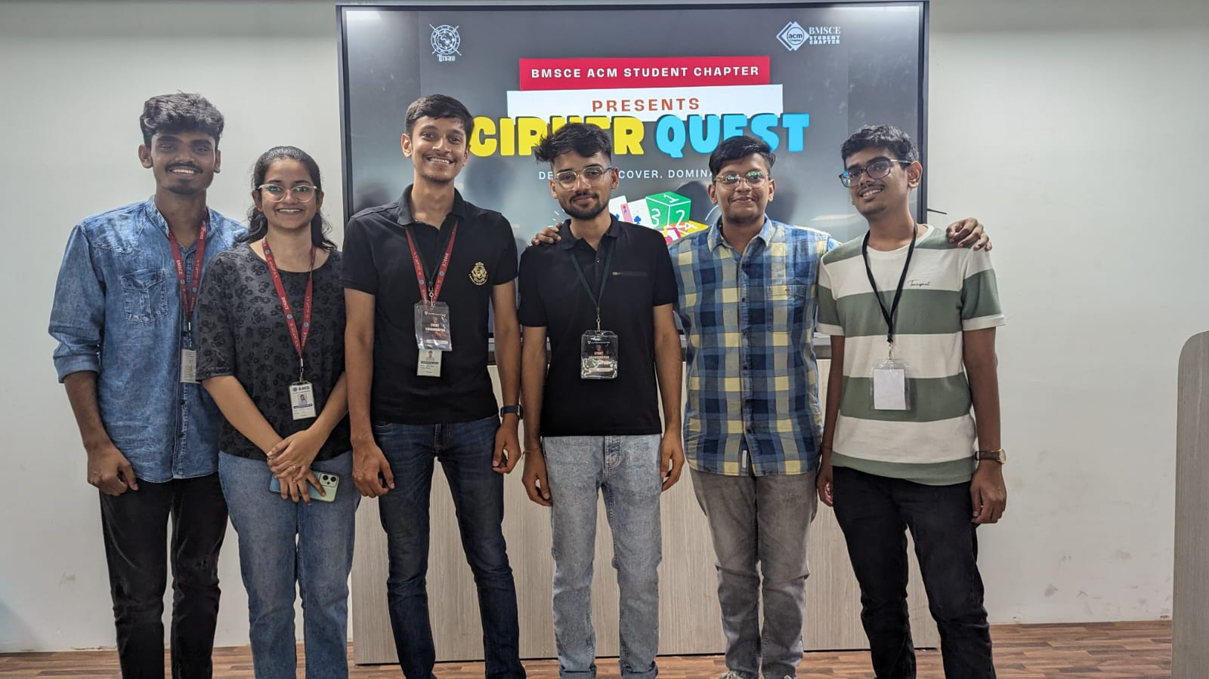

Supporting Documents
a) Attendance sheet
b) Circulars/Brochures
c) Certificates

